**Multiscale Modelling Project**

Problem Statement: Python code for flow through a porous media

Governing equation:

$$u=-\frac{k}{μ}×\frac{dp}{dx}$$

$$or, Q=-\frac{kA}{μ}×\frac{dp}{dx} where, Q=A×u$$

Here, u = fluid velocity

k = the permeability of the porous medium

dp/dx = the pressure gradient along the x-axis

Q = volumetric flow rate

A = cross sectional area

In the code provided, the velocity u is calculated using an upwind scheme based on the sign of the velocity (u >= 0 or u < 0), which determines the direction of the pressure gradient. This upwind scheme is used to approximate the spatial derivative of pressure (dp/dx) in Darcy's law, and is combined with the porosity $∅$ (phi) and other parameters to assemble a coefficient matrix A and right-hand side b for solving the system of equations to obtain the pressure profile p.

Boundary Conditions:

1. Left boundary: phi[0] = 0 - The porosity at the left boundary is set to 0, which means there is no fluid flow into the domain from the left side. This represents a no-flow or impermeable boundary condition at the left boundary.
2. Right boundary: phi[-1] = 0 - The porosity at the right boundary is also set to 0, which means there is no fluid flow out of the domain from the right side. This represents a no-flow or impermeable boundary condition at the right boundary.

These boundary conditions assume that there is no fluid flow across the left and right boundaries of the porous medium in the given simulation. These conditions can be modified according to the specific problem being modeled and the desired behavior at the boundaries.

Flowchart

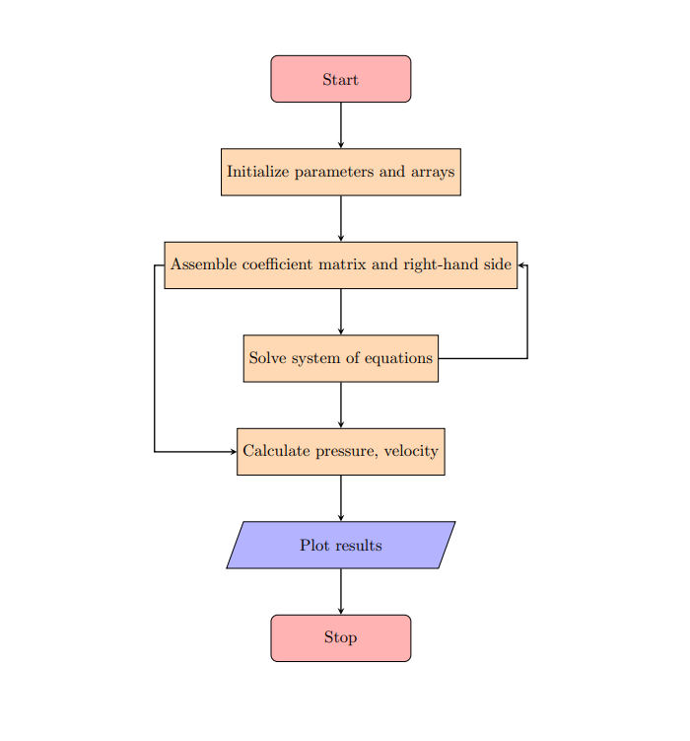

Graphs:

Graph1: Pressure v/s Distance

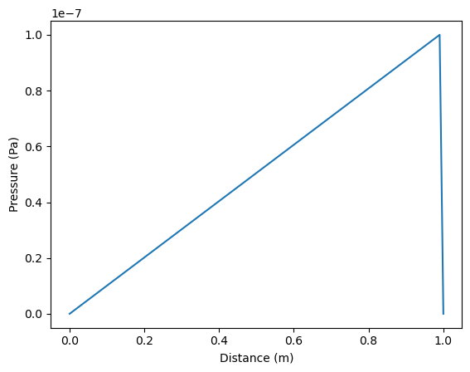

Interpretation: Pressure is increasing linearly as the distance increases. In porous media, the pressure distribution is influenced by the flow of fluid through the porous medium. As it travels through the medium, it faces resistance which causes the pressure to increase. Here, the pressure is increasing linearly, which indicates that the media is isotropic in nature.

Graph2: Velocity v/s Distance

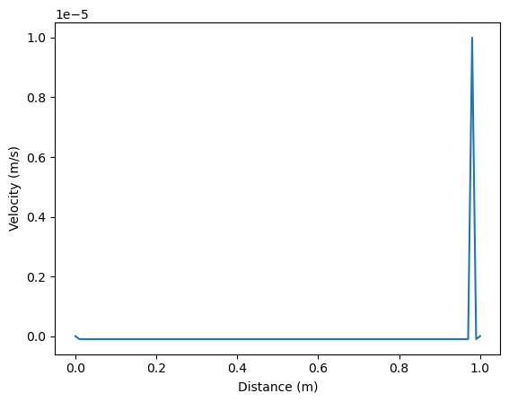

Interpretation: The velocity almost remains constant throughout the profile. However, it decreases a little bit in the beginning due to the increase in porosity at the beginning. It has a spike at the last as the pressure here is zero. And there is a boundary condition for porosity is set to 1 which is a sudden change in boundary condition. This accounts for the abnormal behavior of gthe graph in the last part.

Conclusion:

The profiles developed in porous media is influenced by the complex interactions between the fluid flow and the porous medium's properties, such as porosity, permeability, and boundary conditions.

It depends on a lot of conditions:

1. Porosity: Porosity is the measure of the void space in a porous medium, representing the volume of empty spaces (pores) compared to the total volume.
2. Permeability: Permeability is a measure of how easily a fluid can flow through a porous medium. It depends on the size, shape, and connectivity of the pores.
3. Boundary Conditions: Boundary conditions, such as the flow rate or pressure gradient at the boundaries of the porous medium, can also affect the velocity profile
4. Flow Regime: The flow regime in porous media can vary depending on factors such as the Reynolds number, which is a dimensionless number that describes the ratio of inertial forces to viscous forces in a fluid flow.

Thus we can conclude that the specific behavior of the pressure and velocity distribution in porous media can be highly complex profile and can vary significantly depending on the properties of the porous medium, the fluid flow conditions, and the boundary conditions and other factors. This is done for simple simulation where various factors are kept constant. However, the profiles will be entirely different if one or several factors are changed.